**Research Method Analysis**

**Introduction -**

This report will examine appropriate research methodologies and approaches as part of the research process. It will evaluate research methodologies and processes in application to the research project. It will also evaluate research methodologies and processes in application to a computing research project to justify chosen research methods and research analysis.

**Topic -**

***“Are technology companies responsible for the health, safety and wellbeing of users?”***

**Evaluation of Research used -**

This report will cover the types of research methods that are used in conducting a research with the help of different methods.

**Primary Research :**

This research method involves first hand collection of data by an individual for analysis, study, research, or documentation of the collected information.

**Questionnaire** -

I have formed questions which question participants on digital wellbeing and how it affects their daily schedule. This questionnaire can be answered by different age groups and can be compared with each other to further evaluate on how it impacts on the overall demographic.

**Critical evaluation of Questionnaires -**

**Answers that are not true -**

It will be for a number of factors, including the tendency against social desirability and the desire to preserve privacy. Avoid dishonesty in its tracks by ensuring that respondents respect their anonymity and that the procedure avoids personal profiling.

**Questions that are left unanswered -**

There is a risk that certain queries may be missed or leave unanswered by utilising questionnaires. When questions are not asked, there is always the possibility that they will not be addressed. Online questionnaires give an easy solution to this problem: address the appropriate question. Otherwise, keep your sample quick and your questions uncomplicated and stop query skipping to get stronger completion rates.

**Differences between perception and definition**

The challenge in not asking face-to-face issues to consumers is that each of them can have specific definitions of the query. Without someone to thoroughly clarify the questionnaire to insure that each person has the same interpretation, the findings may be arbitrary. Respondents might have difficulty understanding the significance of some of the queries that might seem obvious to the author. This miscommunication may lead to distorted outcomes. The easiest approach to cope with this problem is to build clear questions that are easy to address.

**Complex to express thoughts and intentions -**

The survey or questionnaire can not completely express the personal responses or emotions of the respondents. Excluding the face-to-face interview, there is no way to track facial tone, emotions or body language. Useful details will go overlooked without such subtleties. Don't get lost trying to read emotion in the results, then go to the Likert scale, the reaction scale that is sometimes used.

**Reasons for choosing Questionnaire -**

**Moderately simple to examine -**

Questionnaires after they have been completed by the participants can be easily examined as its simplicity and the design make it easier to process data quickly and efficiently.

**Recognizable to library staff and directors -**

Questionnaire uses a familiar format and design pattern which can be recognised by all staff members of public libraries and research directors in the field. Which is one of the best methods of collecting data.

**More coverage with less effort -**

An enormous amount of the given population can be reached at moderately minimal effort. It covers more area with less effort without having to meet the participants face to face which in turn saves a lot of time in the long run.

**Easy to oversee -**

Questionnaires are easy to browse through and make quick comparisons with other results and evaluate them without much effort in going through in detail as questionnaires are short and brief.

**Configuration is recognizable to most respondents -**

Questionnaires are widely recognised by the public as the most popular form of data collection method used by researchers for ages. It makes sense to use a questionnaire as a primary method for conducting any sort of research.

**Quick and easy to complete -**

Questionnaires are easy to read and comprehend which requires less effort to go through and make comments and usually takes up very little time to finish the form with ease.

**Google Forms** -

I have prepared forms which are collected from groups of people about a certain issue that bothers or might have issues with, and satisfying solutions to resolve. These are data forms which are collected from groups of people about a certain issue that bothers or might have issues with, and discuss a satisfying solution to resolve the issue.

**Critical evaluation of google forms -**

**Access to the Internet -**

In order to use google forms it is essential to have access to the internet which is not ideal as people may not have access to the internet. It makes collecting data for research more challenging to gather information. People who are not connected will not be able to take part in the research and hence be left out of the research.

**Customisation restriction -**

It does not have enough customization to the design and only users who are experienced with the tools can take full advantage of it. Creating a google form requires a skill of its own and more feathers to the form by not knowing how it works makes it difficult and restricts the use of certain methods that can help improve the way the data is collected.

**Security Issues -**

There are a variety of security issues. The user has to create a good password and protect it to increase the level of security. Not only that but, there may be vulnerabilities in the software that can affect the data in some manner. Not every software is 100% protected from any threats which can change the outcome of the research by manipulation of the information collected.

**Data restrictions -**

There are several restrictions on the functionality of this device. Texts up to 500 Kb; images up to 2 Mb; and spreadsheets up to 256 cells or 40 sheets. This can limit the data collected and stored which reduces the amount of options available for the participants to express their views of the topic.

**Reasons for choosing Google Forms -**

**Meeting objectives and Surveys -**

Google form give the option to suggest a significant research questions, select an example bunch from the populace utilizing a suitable examining procedure, plan a poll without question predisposition, direct the overview, break down the information utilizing diagrams, information tables, and turn outlines, and reach determinations from the information. Google Forms is a valuable apparatus for meeting goals.

**Different types of questions -**

Google Forms permits you to ask both open-finished and shut finished inquiries. You can utilize drop down menus, numerous decision agendas, rating scales, and short answers content boxes to assemble information. The following are the kinds of inquiries you can use in a Google Form such as Content, Passage Text, Different Choice, Check boxes, Browse a rundown, Scale, Lattice, Date,Time, etc.

**Controls Data Entry and Validations -**

Information approval is a standard applied to the information section to ensure that the data is right as well as helpful. Google Forms offers numerous alternatives for controlling answers given by respondents. Questions can be set to keep respondents from avoiding an inquiry. A number or content can be confined to a particular passage, character check, or range. An agenda can have the quantity of alternatives chosen restricted. Also, the request for decisions for an inquiry can be rearranged to stay away from arrangement inside a rundown impacting determination. Approval choices given by Google Forms help to improve the nature of the information recorded.

**Professional looking Forms -**

Google Forms encourages you to make an expert looking structure. Topics are accessible permitting you and your understudies to choose from more than twenty pre-set plans. Also, a custom alternative advances inventiveness. The header, content, structure foundation, and page foundation would all be able to be tweaked. It is amusing to investigate the library of header pictures. One element I like is the capacity to set the page foundation. You can transfer an image, take a preview, or burden a picture from a URL or Google Drive to make a custom look. With such a significant number of web applications constraining the inventive procedure, it is invigorating that structure appearance isn't limited to just a couple of formats in Google Forms.

**Different ways to manage forms -**

Google Forms lets you gather information utilizing numerous strategies. A structure can be remembered for the body of an email permitting a respondent to present their reactions from their Inbox. A connection can be produced permitting respondents to address the inquiries utilizing an online structure. Code can be created and afterward implanted into a blog or site page as another alternative for information assortment. Too, if a paper/pencil technique is favored the structure can be changed over into a PDF document utilizing Google Chrome.

**Secondary Research :**

Type of research approach and methodologies you are likely to use, and reasons for your choice:

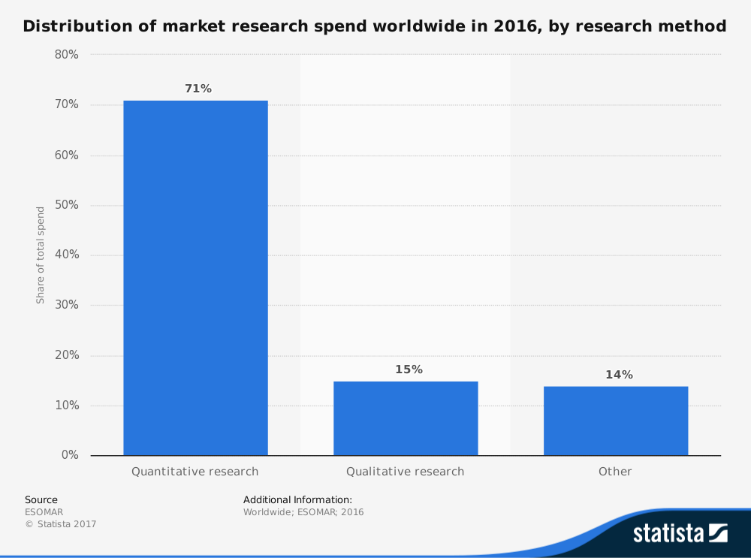

**Quantitative Research** -

**Critical evaluation of Quantitative Research** -

This was performed in a local area which consists of a small group of people who have provided information to help support my research. This type of research is based on data that is collected in general which is from a specific region or area which allows to indicate how different regions reflect upon a specific data.

**Concentration on the figures.**

Quantitative analysis may be constrained in its exploration of specific, predictive interactions that may cause researchers to neglect wider concepts and interactions. By concentrating solely on numbers, you run the risk of overlooking unexpected or large-scale details that could help your company.

**Difficulty in building up a testing model -**

In doing quantitative study, you need to properly establish a theory and set up a data collection and analysis process. Any mistake in your design, prejudice on the part of the study, or mistake in execution will invalidate any of your tests. Even a theory may be arbitrary, particularly if you have a particular query that you already know you want to prove or disprove.

**Misleading information -**

Most people believe that quantitative analysis, focused on data, is more reliable or empirical than retrospective, qualitative research. However, all forms of analysis may be arbitrary and deceptive. The views and prejudices of the study are also likely to have an effect on quantitative approaches to collecting knowledge. In addition, the effect of this prejudice appears sooner in the quantitative analysis cycle than in qualitative study.

**Reasons for choosing Quantitative research -**

**Popular form of research method used worldwide -**

As shown by the graph above, the quantitative research method is widely used by market distributors to collect data. As it is performed in a local area which consists of a small group of people who have provided information to help support my research. This type of research is based on data that is collected in general which is from a specific region or area which allows to indicate how different regions reflect upon a specific data.

**Quantitative method has massive coverage**

At the point when you can examine a bigger example size for any theory, at that point it is simpler to arrive at a precise summed up end. The extra information that you get from this work gives the result more prominent believably in light of the fact that the factual investigation has more profundity to survey. A bigger example makes it more outlandish that anomalies in the investigation gathering can antagonistically affect the outcomes you need to accomplish fairly.

**Data can be retrieved immediately**

Specialists gather data for the quantitative research process in continuous situations so factual examination can happen very quickly. Investigations, reviews, and meetings give prompt answers that become valuable from an information focused methodology. Less postponements in the obtaining of these assets makes it simpler to discover relationships that in the long run lead toward a helpful end.

**Quantitative research utilizes unstructured examples.**

At the point when explore members speculate that an investigation needs to accomplish a particular outcome, at that point their own inclination can go into the information range. The appropriate responses gave on the included materials are fractional facts or through and through lies as an approach to control the work. That is the reason the quantitative methodology is so valuable when attempting to contemplate a particular theory inside a huge populace segment.

**Qualitative Research-**

This research was done to identify the reason and motivation for a problem and offers ideas to the problem with hypotheses to predict the outcome and following trends of the data.

**Critical evaluation of qualitative research -**

**That's not a statistically representative method of data collection -**

There is little objective analysis of the qualitative study method. This can just include analysis details from a distance. Responses to this form of study can not typically be calculated. Just similarities are necessary, so this appears to produce replication of data over time. If objective results are needed, qualitative analysis is not the type of study that should be used.

**It depends on the expertise of the researcher -**

The evidence obtained by qualitative analysis relies on the expertise of the researchers participating in the project. Sector-specific details must be obtained by a researcher who is acquainted with the sector. Researchers must always have excellent listening abilities, have the confidence to pose follow-up questions, and be willing to develop professional relations with the participants in order to insure that they are correct using the data.

**Data can be lost -**

For data to be obtained, qualitative analysis researchers must understand the results. It ensures that there is a degree of confidence inherent in the data collection phase that certain methods of analysis do not need. Scientists who are unable to identify the requisite evidence as they analyse it will miss it, which limits the precision of the outcomes of qualitative analysis efforts.

**Difficult to manipulate results -**

Qualitative analysis is focused on human observations, it is almost difficult to replicate the findings that have been established. Perhaps the same person can have a different perspective tomorrow than they do today. It suggests that the evidence obtained by qualitative analysis may be difficult to validate, which can cause others to doubt the results that researchers have produced by this method.

**Reasons for choosing Qualitative research -**

**Qualitative research can be more targeted -**

If you want to compare productivity across an entire organization, all parts, process, and participants need to be accounted for. Qualitative research can be far more concentrated, sampling specific groups and key points in a company to gather meaningful data. This can both speed the process of data capture and keep the costs of data-gathering down.

**Qualitative research allows researchers to speculate on their own -**

Qualitative Research catch permits scientists to be undeniably increasingly theoretical about what zones they decide to examine and how to do as such. It permits information capture to be provoked by a specialist's instinctual or 'gut feel' for where great data will be found.

**More Flexibility -**

Qualitative Research gives a significantly more adaptable methodology. On the off chance that valuable bits of knowledge are not being caught scientists can rapidly adjust questions, change the setting or some other variable to improve reactions.

**Mixture Research -**

This type of research was used to collect both Quantitative and Qualitative researches that include collecting, research, analysing data that have been collected with a better understanding of the research problem which are Quantitative or Qualitative.

**Critical evaluation of mixture research -**

**Evaluation in more complex -**

Mixed method experiments are difficult to schedule and perform. They involve meticulous preparation to identify all facets of the analysis, including the test sample for qualitative and quantitative portions (identical, embedded or parallel); sequencing (sequence of qualitative and quantitative portions); and the data management strategy. The synthesis of qualitative and quantitative data during study is also a daunting process for many researchers.

**Required resources are increased -**

Mixed method experiments are labour-intensive and take more energy and time than those required to carry out a single method analysis.

**Involves researchers from different fields -**

The performance of high-quality mixed approach studies involves a multidisciplinary team of scholars, who must be accessible to approaches that might not be their field of practise, in the context of a wider analysis. Seeking qualitative professionals who are often confident presenting quantitative studies, and vice versa, may be difficult in a variety of environments.

**Reasons for choosing Mixture research -**

**Gives qualities that balance both quantitative and qualitative research.**

Quantitative research is frail in understanding the unique circumstance or setting in which individuals carry on, something that subjective research compensates for. Then again, subjective research is viewed as insufficient on account of the potential for one-sided translations made by the scientist and the trouble in summing up discoveries to an enormous gathering. Quantitative research doesn't have these shortcomings. In this manner, by utilizing the two sorts of research, the qualities of each approach can compensate for the shortcomings of the other.

**Better development and instrumental context -**

By using qualitative research it is conceivable to assemble data about a specific theme or build so as to build up an instrument with more prominent development legitimacy, i.e., that gauges the build that it plans to quantify.

**Better understanding of the research -**

It gives an increasingly complete and far reaching comprehension of the examination issue than either quantitative or subjective methodologies alone. It also helps in giving better explanations about how casual processes work.

**Research Methodologies used -**

**Ontology -**

This research does not use an ontology method of research which involves a broader study of concepts which are based on reality and beliefs that is based on general knowledge which is real and not based on studies and researches that have been done by experts and professionals.

**Critical evaluation of ontology method -**

**Inaccurate data -**

Even after collecting sufficient amounts of data to come to a reasonable conclusion there will still be more data to collect. There will be more options that will be required to be considered.

**Incomprehensible amount of information -**

There is too much data that is required to be analysed that it would take a long time to make a conclusion. It would not be possible to process the amount of information that had been collected.

**Epistemology -**

I have used epistemology in my research that is a theoretical knowledge which has been proven with extensive research and analysed thoroughly through documentation and historical data that have been proven with evidence supporting theories and knowledge with research data, statistics, analysis, evaluations and philosophies to come to a conclusion.

**Critical evaluation of epistemology method -**

**Data available online -**

These are data that are available online that can be used to support the research. Data gathered from different resources that are proven by experts and professionals in the field. This is one of the most popular forms of research methods. It is free to use in some cases or may be charged some amount to use the data.

**Public libraries -**

This is the most convenient of research that is used to gather data for research which are filled with hundreds of books with research articles, documentations, journals, newspapers that are preserved from the past to be analysed. They also have huge collections of selections from different publishers and authors for the public to use.

**Commercial information sources -**

These are commercial outlets that include newspapers, journals, magazines, radio and T.V stations are great resources and for reviews. Commercial information are data that are collected recently which may consist of marketing research, demographic segmentations political agenda and can be used in documentation, economic development

**Reasons for choosing Epistemology research method -**

**Uses proven facts to support research -**

These are research data that are tested and proven by experts in the field with resources backing up the information. It helps to strengthen the arguments about the research.

**Data available easily -**

It is easier to get data over the internet with researchers already providing their research information collected and archived over the internet. Data gathered from different resources that are proven by experts and professionals in the field. This is one of the most popular forms of research methods.

**Reasons for choosing this research project -**

* Reasons for choosing the project which were linked to other subjects that i was studying, I also have a personal interest in this field of research which helped me get motivated in proceeding with the research as future plans that include gaining knowledge and skills to improve my understanding of the topic as it is important to make a reasonable conclusion based on the research that I have collected.
* As I’m part of learning how tech works and how technology companies produce new software, I’m interested in how technology companies are responsible for the health, safety and wellbeing of their users.

**Skills that I gained after my research was completed-**

* A Deeper understanding of research methodologies
* Presentation skills
* Report writing skills
* Planning
* Time management
* Collection of data
* Analysis and evaluation of data
* Gathering data from secondary resources

**Graphs and Charts Analysis -**

The data is gathered and analysed from primary and secondary which will be presented in the form of analysed text data which will be compared to show how they would be in terms of local verses compared to the rest of the world. This will demonstrate digital wellbeing with a more clear perspective to explore their function in a wider view.

**Checking phones per day -**

According to my primary research, about 36% of millennials check their phones per day while the secondary research shows that 64% of millennials check their phones per day.

**Technology Companies user manipulation -**

According to my primary research 85% of teens believe that technology companies manipulate users to spend more time on their devices while the secondary research shows that 72% of teens believe that technology companies manipulate users to spend more time on their devices.

**Social Media Usage -**

According to my primary research about 86% of teens use social media multiple times a day, with 14% saying they use it “almost constantly”, while the secondary research shows that 70% of teens use social media multiple times a day, with 16% saying they use it “almost constantly”.

**Tinder Swipes per day -**

According to my primary research about 1.6bn Swipes are made per day on Tinder alone. That’s more than 18,500 every second, while the secondary research shows that 1.6bn Swipes are made per day on Tinder alone. That’s more than 18,500 every second.

**Users on Youtube per day -**

According to my primary research about 99% of teens and young adults watch youtube videos a day, while the secondary research shows that about 1.9 billion people use Youtube daily.

**Users on Facebook -**

According to my primary research about 20% of teens and young adults use facebook daily, while the secondary research shows that about 2.27 billion people use Facebook worldwide.

**Users who use the Internet -**

According to my primary research 99% of people use the internet to browse at home, while the secondary research shows that about 4 billion people use the internet. That’s more than half the world’s population.

**Time spent on social media -**

According to my primary research about 99% of people spend time on social media, while the secondary research shows that about 99.9% of adults spend more than 11 hours everyday engaging with some form of media.

**Conclusion -**

In conclusion, this report has examined appropriate research methodologies and approaches as part of the research process. It evaluates research methodologies and processes in application to your research project. It also evaluates research methodologies and processes in application to a computing research project to justify chosen research methods and research analysis.

**Resources -**

Survey Anyplace. 2020. *10 Advantages And Disadvantages Of Questionnaires - Survey Anyplace*. [online] Available at: <https://surveyanyplace.com/questionnaire-pros-and-cons/> [Accessed 4 May 2020].

DataScope. 2020. *Advantages And Disadvantages Of Google Forms | Datascope*. [online] Available at: <https://www.mydatascope.com/blog/en/2018/06/15/advantages-and-disadvantages-of-google-forms/> [Accessed 4 May 2020].

Gaille, B., 2020. *25 Advantages And Disadvantages Of Qualitative Research*. [online] BrandonGaille.com. Available at: <https://brandongaille.com/25-advantages-disadvantages-qualitative-research/> [Accessed 4 May 2020].

The Balanced Small Business. 2020. *Here Are The Advantages And Disadvantages Of Quantitative Research*. [online] Available at: <https://www.thebalancesmb.com/quantitative-research-advantages-and-disadvantages-2296728> [Accessed 4 May 2020].

Pcmh.ahrq.gov. 2020. *Mixed Methods: Integrating Quantitative And Qualitative Data Collection And Analysis While Studying Patient-Centered Medical Home Models | PCMH Resource Center*. [online] Available at: <https://pcmh.ahrq.gov/page/mixed-methods-integrating-quantitative-and-qualitative-data-collection-and-analysis-while> [Accessed 4 May 2020].

Evalued.bcu.ac.uk. 2020. *Evalued*. [online] Available at: <http://www.evalued.bcu.ac.uk/tutorial/4a.htm> [Accessed 14 May 2020].

Love, C. and &rarr;, V., 2020. *5 Reasons To Use Google Forms With Your Students - Technokids Blog*. [online] TechnoKids Blog. Available at: <https://www.technokids.com/blog/apps/reasons-to-use-google-forms-with-your-students/> [Accessed 14 May 2020].

Garage, G., 2020. *15 Advantages And Disadvantages Of Quantitative Research*. [online] Green Garage. Available at: <https://greengarageblog.org/15-advantages-and-disadvantages-of-quantitative-research> [Accessed 14 May 2020].

Poppulo. 2020. *10 Advantages And Disadvantages Of Qualitative Research*. [online] Available at: <https://www.poppulo.com/blog/10-advantages-and-disadvantages-of-qualitative-research/> [Accessed 14 May 2020].

Ltd, W., 2020. *Mixed Methods Research*. [online] Resourcecentre.foodrisc.org. Available at: <http://resourcecentre.foodrisc.org/mixed-methods-research_185.html> [Accessed 14 May 2020].

Ontotext. 2020. *What Are Ontologies And What Are The Benefits Of Using Ontologies*. [online] Available at: <https://www.ontotext.com/knowledgehub/fundamentals/what-are-ontologies/> [Accessed 14 May 2020].